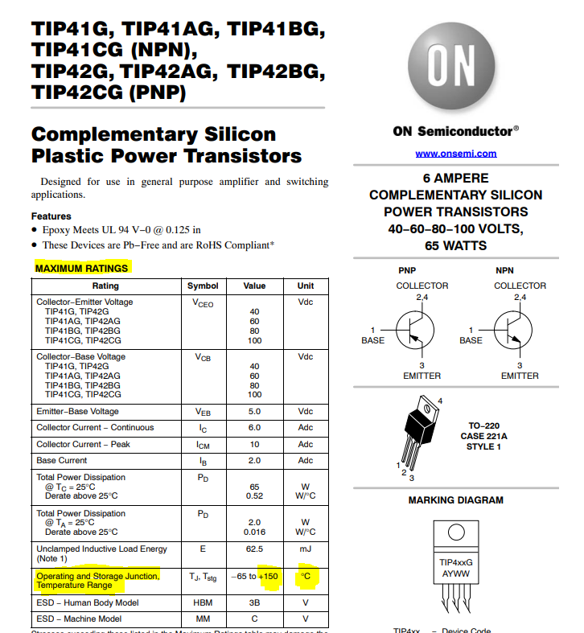

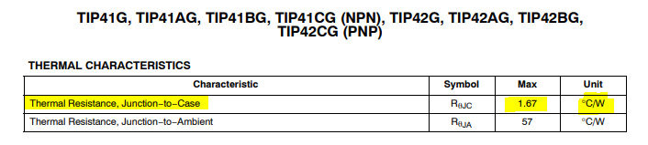

Heatsink Power Dissipation Calculations for the **HSE-B20254-035H**:

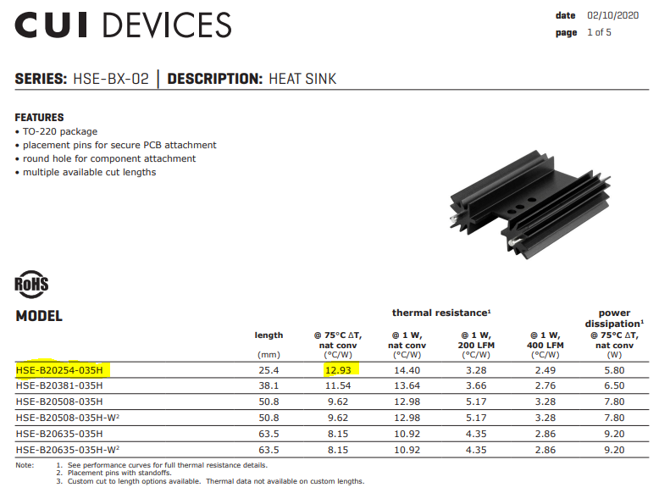HSE-B20254-035H Heat Sink, $Thermal Resistance =\frac{12.93℃}{1W}$

TIP41, $Thermal Resistance=\frac{1.67℃}{1W}$

TIP41, $Maximum Temperature=150℃$

Add Thermal Resistances of the heat sink and the TIP41:

$$Total Thermal Resistance=\frac{12.93℃}{1W}+\frac{1.67℃}{1W}=\frac{14.6℃}{1W}$$

Design for temperature less than Max TIP Temperature:

Factor in ambient temperature:

$${MaxTempDesign}_{W/ambient}=135℃-Ambient$$

$${MaxTempDesign}_{W/ambient}=135℃-25℃$$

$${MaxTempDesign}_{W/ambient}=110℃$$

Maximum Power Dissipation Calculations:

$$Total Thermal Resistance=\frac{14.6℃}{1W}$$

$${MaxTempDesign}_{W/ambient}=110℃$$

$$\frac{14.6℃}{1W}=\frac{110℃}{Maximum Power Dissipation}$$

$$Maximum Power Dissipation=\frac{1W×110℃}{14.6℃}$$

$$Maximum Power Dissipation=\frac{1W×110℃}{14.6℃}$$

$$Maximum Power Dissipation=\frac{110W}{14.6}$$

$$Maximum Power Dissipation=7.534 watts$$

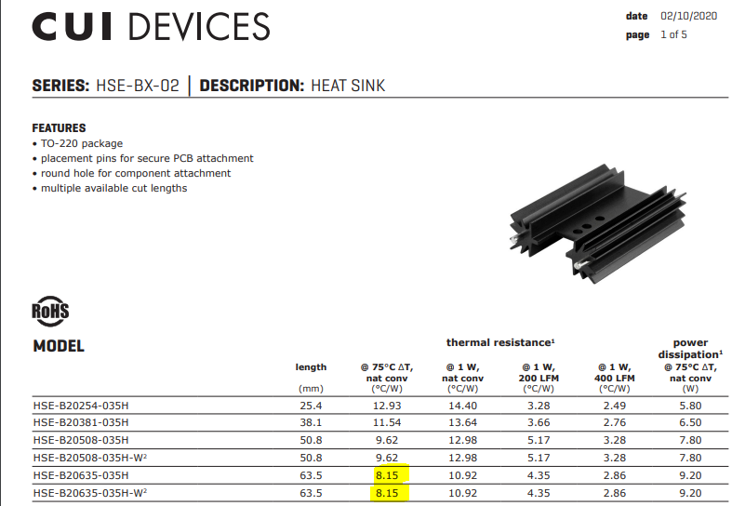**The HSE-B20254-035H with a TIP41 is capable of safely dissipate 7.564 watts.**

Heatsink Power Dissipation Calculations for the **HSE-20635-035H**:

HSE-B20254-035H Heat Sink, $Thermal Resistance =\frac{8.15℃}{1W}$

TIP41, $Thermal Resistance=\frac{1.67℃}{1W}$

TIP41, $Maximum Temperature=150℃$

Add Thermal Resistances of the heat sink and the TIP41:

$$Total Thermal Resistance=\frac{8.15℃}{1W}+\frac{1.67℃}{1W}=\frac{9.82℃}{1W}$$

Design for temperature less than Max TIP Temperature:

Factor in ambient temperature:

$${MaxTempDesign}_{W/ambient}=135℃-Ambient$$

$${MaxTempDesign}_{W/ambient}=135℃-25℃$$

$${MaxTempDesign}_{W/ambient}=110℃$$

Maximum Power Dissipation Calculations:

$$Total Thermal Resistance=\frac{9.82℃}{1W}$$

$${MaxTempDesign}_{W/ambient}=110℃$$

$$\frac{9.82℃}{1W}=\frac{110℃}{Maximum Power Dissipation}$$

$$Maximum Power Dissipation=\frac{1W×110℃}{9.82℃}$$

$$Maximum Power Dissipation=\frac{1W×110℃}{9.82℃}$$

$$Maximum Power Dissipation=\frac{110W}{9.82}$$

$$Maximum Power Dissipation=11.202 watts$$

**The HSE-B20254-035H with a TIP41 is capable of safely dissipate 11.202 watts.**

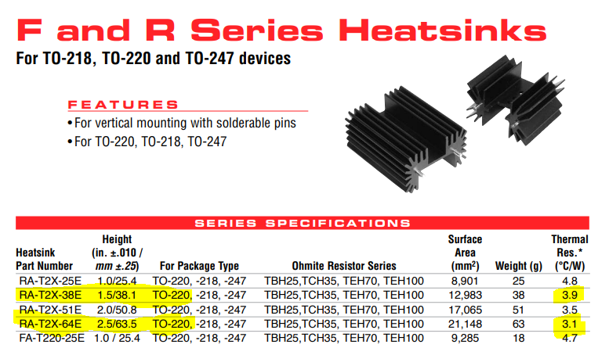

Heatsink Power Dissipation Calculations for the **RA-T2X-38E & RA-T2X-64E:**

RA-T2X-38E $Thermal Resistance =\frac{3.9℃}{1W}$

$$Total Thermal Resistance=\frac{3.9℃}{1W}+\frac{1.67℃}{1W}=\frac{5.57℃}{1W}$$

$$RA-T2X-38E Maximum Power Dissipation=\frac{110W}{Total Thermal Resistance}=\frac{110W}{5.57}$$

$$RA-T2X-38E Maximum Power Dissipation=19.57 watts$$

RA-T2X-64E $Thermal Resistance =\frac{3.1℃}{1W}$

$$Total Thermal Resistance=\frac{3.1℃}{1W}+\frac{1.67℃}{1W}=\frac{4.77℃}{1W}$$

$$RA-T2X-64E Maximum Power Dissipation=\frac{110W}{Total Thermal Resistance}=\frac{110W}{4.77}$$

$$RA-T2X-64E Maximum Power Dissipation=23.1 watts$$